***PC Based Data Acquisition System Using SPI and I2C,UART protocols***

Main idea is to implement sensor system which can monitor parameters like temperature, pressure, humidity, light intensity …etc. In general sensors are effected by  atmosphere changes but these changes can be converted in to change in voltage.

Data Acquisition refers to reading the data continuously from any sensor. Here we are continuously monitoring the data through PC. We are concentrating mostly on serial communication.

The data which we are receiving from the sensor is received by the microcontroller using ADC. Data monitoring is done in PC and for communication serial port communication is used. We can get the information like Date and Time along with our data through I2C.

 The data that is stored in the PC is easier to monitor or retrieve at any time compared to storing in a particular memory. Nowadays we are using the same process as storing the data in the PC in any kind of industries.

Here we are monitoring the light intensity.

***BLOCK DIAGRAM***

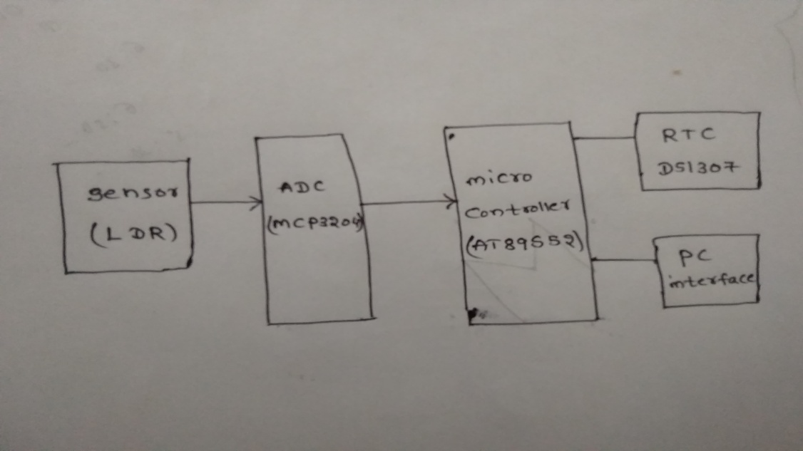

***Tools used***

Software and hardware.

Hardware consists of micro controller(AT89S52),I2C device(RTC-DS1307),SPI device(ADC-MCP3204),LDR(light dependent resistor-sensor),UART (for pc connection),RS232 cable.

Software consists of protocols of I2C,SPI and UART protocols.

***Micro controller***

256 x 8-bit Internal RAM

40 pin IC

32 Programmable I/O Lines

3 - 16-bit Timer/Counters

Eight Interrupt Sources

Full Duplex UART Serial Channel

Low-power Idle and Power-down Modes

Watchdog Timer

***UART***

UART is universal asynchronous receiver and transmitter.

It consists of 4 registers

SBUF-serial buffer is used to transmit and receive the data(1 byte).

SCON-serial control register .

TMOD,TH1,TL1 are used for baud rate setting.

***I2C***

I2C is inter integrated circuit designrd by Philips.

It is used for on board ic communication.

It is a 2 wired communication bus.(SDA,SCL).

It is half duplex synchronous serial communication.

It is used for short distance communication.

I2C bus events

1.I2C start bus.

2.I2C write bus.

3.I2C read bus.

4.I2C acknowledgement bus.

5.I2C no acknowledgement bus.

6. I2C stop bus.

***SPI***

SPI is serial peripheral interface.

SPI is designed by Motorola.

SPI is 4 wired communication(MOSI,MISO,CLK,Chip select/slave select).

SPI is full duplex synchronous serial communication.

I used MCP3204 ADC for analog to digital conversion.

***working***

Micro controller is interfaced with RTC,ADC and PC using sotware.

Software of i2c,spi,uart are dumped into microcontroller using isp(internet service provider which is used for transmission of data) software.

After dumping the program into the micro controller. when ever light intensity increases on the LDR then the changes in the resistance are seen that changed resistance values are seen in the PC if light intensity decreases the resistance value decreases these are continuosly monitored in the PC ,UART is responsible to see the values on PC. I2C is used for real time clock for continuos monitoring of LDR. SPI is used for ADC .

***Applications***

Street lights automatically ON and OFF when intensity is increasing and decreasing.